DoDAF DoW – Agentic process flow using CrewAI Design Document
Table of Contents
DoDAF DoW – Agentic process flow using CrewAI 1
Design Document 1
Full Flow All components 2
Environment 3
DoDAF SE Stages -> DoDAF 2.0 Artifacts Mapping 3
DoDAF-SE Pipeline — Component Usage by Stage 4
Stage 1 — Intake & Fit-for-Purpose (F2P Gate) 4
Flow diagram: 5
Stage 2 — ICD Generation (Capability Definition + DOTMLPF-P) 5
Flow Diagram: 6
Stage 3 — Operational Views (OV-1, OV-2, OV-3) 6
Flow Diagram: 7
Stage 4 — System Views (SV / SvcV) 7
Flow Diagram: 8
Stage 5 — Standards Views (PV / StdV) 8
Flow Diagram: 9
Stage 6 — Final Summary & Fit-For-Purpose Consolidated View 9
Flow Diagram: 10
Sequence diagram showing full flow 10
High level Component Diagram 11
DoDAF Architecture Repository – Schema 12

Full Flow All components
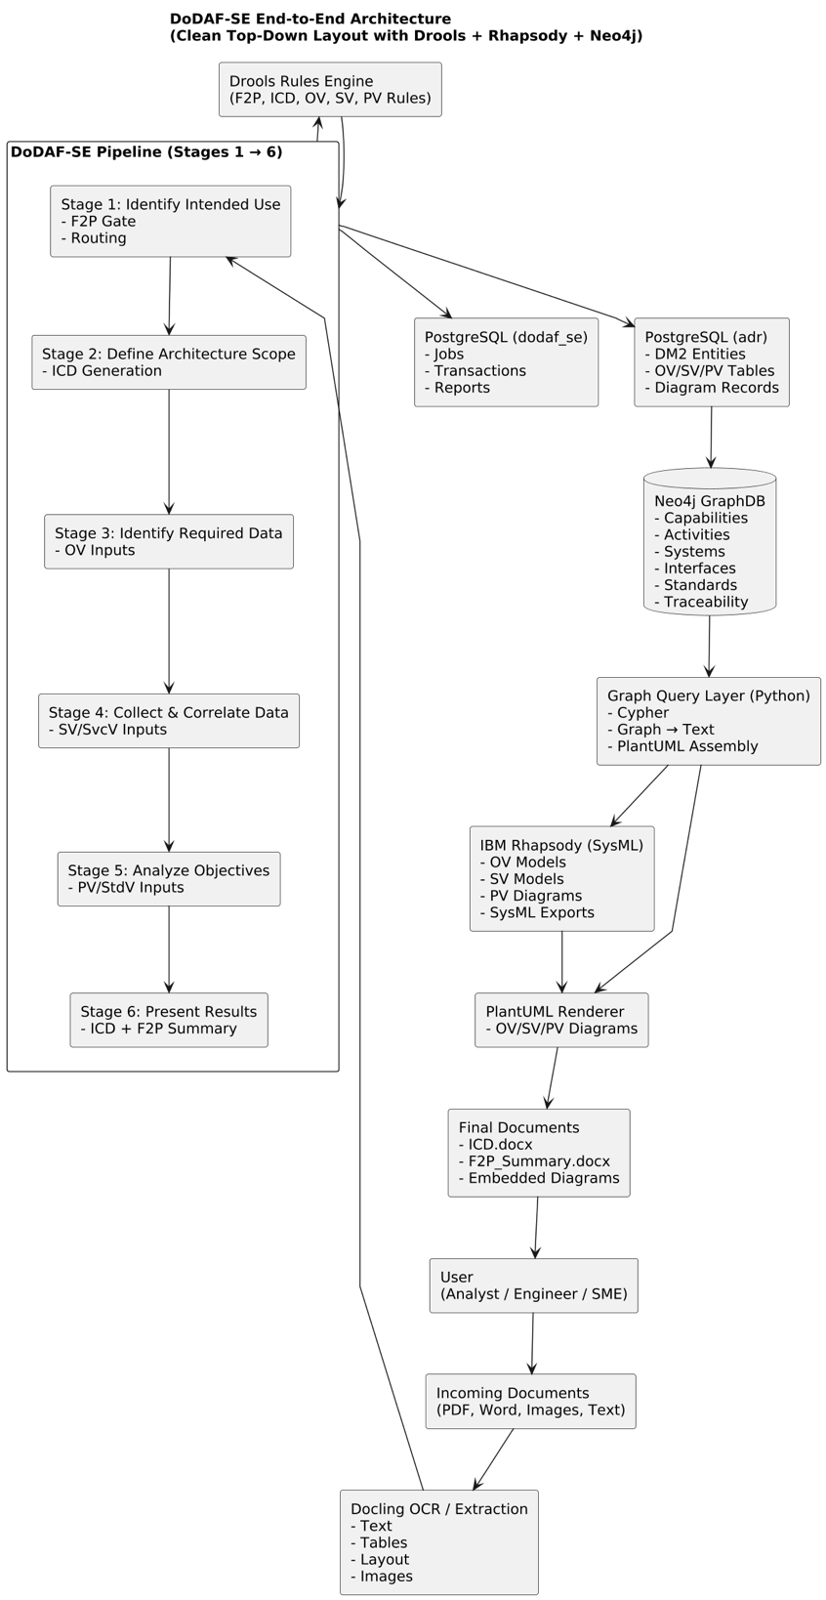

Environment
Development IDE – VSCode, Agents – CrewAI, CrewAI Enterprise Studio
Component | Purpose
Docling | OCR + PDF ingestion + text extraction (mission context, constraints, diagrams)
Milvus (VectorDB) | Retrieve related prior jobs + global DoDAF knowledge (RAG)
Drools (Rules Engine) | F2P validation rules, routing decisions, classification
PostgreSQL | Store extracted text, Stage-1 results, F2P Manifest
Redpanda Kafka | Console streaming, stage status events
MinIO | Raw document storage (uploads, extracted images)
Neo4J | Store operational activities and relationships
IBM Rhapsody | IBM Rhapsody is used to generate authoritative SysML and DoDAF-compliant architecture models and diagrams, ensuring formal traceability, engineering accuracy, and seamless integration with DoD systems-engineering workflows.

DoDAF SE Stages -> DoDAF 2.0 Artifacts Mapping
DoDAF-SE Stage | Purpose | Primary DoDAF Artifacts Produced / Used
Stage 1 — Identify Intended Use (F2P Gate) | Intake, classification, routing, extract mission context | • AV-1 Overview Information• High-level capability needs• Initial Purpose & Scope• F2P Decision Record (internal)
Stage 2 — Define Architecture Scope (ICD) | Full ICD creation: capability definition, gaps, DOTMLPF-P | ICD (Integrated Capabilities Document) containing:• Capability Requirements (CV-1/CV-2 content)• Capability Gaps (CV-3 content)• Operational Context (OV-1 text elements)• DOTMLPF-P Analysis (DoDAF: PV/Activity input)• Constraints + Assumptions (AV-1/AV-2 style)
Stage 3 — Identify Required Data (Operational Views) | Build operational activities, flows, nodes | OV (Operational Viewpoint):• OV-1 High-Level Operational Concept• OV-2 Operational Resource Flow• OV-3 Operational Activity Models• OV performers + nodes (DM2: Performer, Activity)
Stage 4 — Collect & Correlate Data (System Views) | Build system functions, components, interfaces | SV / SvcV (System & Service Views):• SV-1 Systems Interface Description• SV-2 System Resource Flow• SV-4 Functional Models• SvcV-1/2 if services identified• System nodes, components, ports (DM2 System elements)
Stage 5 — Analyze Objectives (Standards Views) | Align systems + activities to standards and constraints | PV (Project Viewpoint) / StdV (Standards Views):• StdV-1 Standards Profile (e.g., NIST/DoD/IC)• StdV-2 Standards Forecast• Platform constraints / compliance mappings• Policy + Interoperability constraints
Stage 6 — Present Results (Summary + F2P) | Consolidate all stages into final reports | Final Fit-For-Purpose (F2P) View:• Consolidated ICD• OV + SV + PV diagram sets• Traceability Matrices (OV→SV, SV→PV)• High-level summary (AV-1 consolidation)• Rhapsody / PlantUML diagram set exports

DoDAF-SE Pipeline — Component Usage by Stage
This pipeline implements a DoDAF 2.0, JCIDS-aligned 6-Stage architecture development process using hybrid AI (CrewAI + LLMs), a rules engine (Drools), vector-based memory (Milvus), a DoDAF knowledge graph (Neo4j), and enterprise repositories (PostgreSQL + MinIO).
Below is the exact mapping of which components are used in which stage.

Stage 1 — Intake & Fit-for-Purpose (F2P Gate)
Purpose:
Ingest, classify, extract, validate, and produce the Stage-1 routing manifest.
Components Used
- Docling — OCR, PDF text/layout extraction
- Milvus (VectorDB) — Retrieve prior knowledge + store Stage-1 chunks
- Drools — F2P rules, classification, routing logic
- PostgreSQL — Store extracted text + F2P manifest
- MinIO — Store uploaded files and extracted images
- Redpanda (Kafka) — Console updates & job status events
- IBM Rhapsody - project initialization, define model namespace, prepare structure for upcoming OV/SV artifacts

Flow diagram:
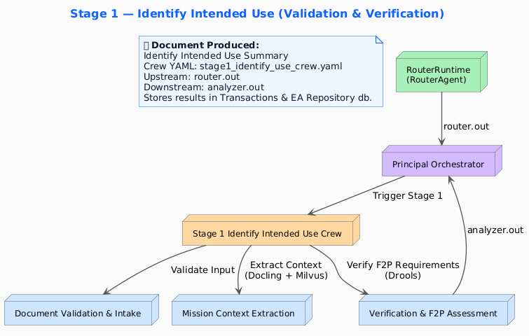

Stage 2 — ICD Generation (Capability Definition + DOTMLPF-P)
Purpose:
Generate the full ICD document: executive summary → capability needs → gaps → DOTMLPF-P → recommendations.
Components Used
- Milvus — Retrieve Stage-1 + DoDAF ICD spec chunks; store Stage-2 chunks
- Drools — ICD structure rules, DOTMLPF-P completeness validation
- PostgreSQL — Persist ICD sections (transaction + master)
- MinIO — Store ICD Markdown/DOCX files
- Redpanda — Pipeline console streaming
- Docling (optional) — If ICD references embedded diagram
- IBM Rhapsody - Create initial SysML blocks for capabilities, Establish structure for future traceability, auto-generate model elements from ICD sections

Flow Diagram:
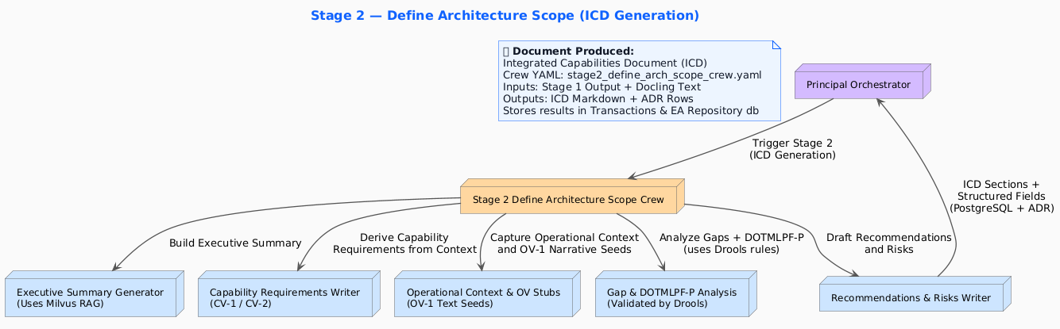

Stage 3 — Operational Views (OV-1, OV-2, OV-3)
Purpose:
Generate OV concepts, operational nodes, flows, and activity models.
Components Used
- Milvus — Retrieve ICD + Stage-1 + OV definitions; store OV chunks
- Drools — Operational activity/flow validation rules
- Neo4j (DoDAF Graph) — Store OV nodes, flows, and relationships
- PostgreSQL — Store OV-1 narrative, OV-2 matrices, OV-3 models
- Redpanda — Console updates
- IBM Rhapsody - OV-1 operational concept diagrams, OV-5 activity models, OV-2 node and flow diagrams

Flow Diagram:
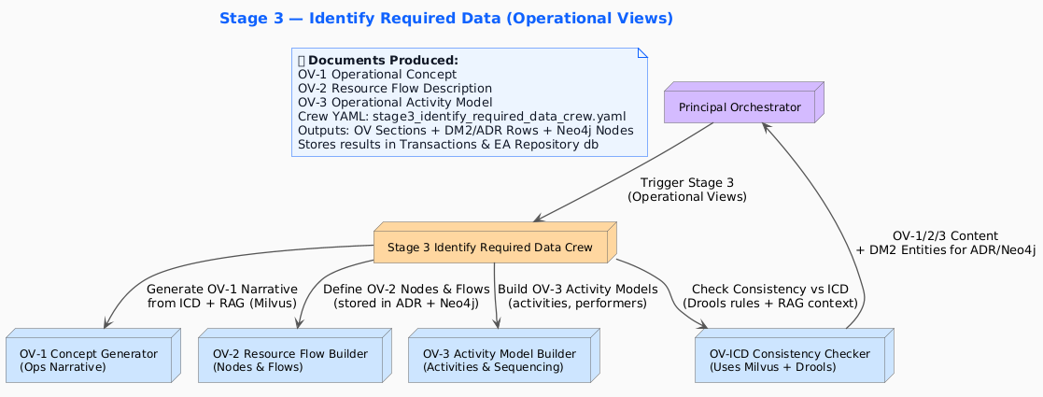

Stage 4 — System Views (SV / SvcV)
Purpose:
Generate system functions, component mappings, and system interfaces based on operational activities.
Components Used
- Milvus — Retrieve OV + ICD + system-mapping context; store SV chunks
- Drools — System-to-activity traceability rules
- Neo4j — Store system nodes, components, interfaces
- PostgreSQL — Persist SV/SvcV sections
- Redpanda — Pipeline updates
- IBM Rhapsody - System block definition (SV-1), System interfaces (SV-2), Sequence/Activity diagrams for system behavior

Flow Diagram:
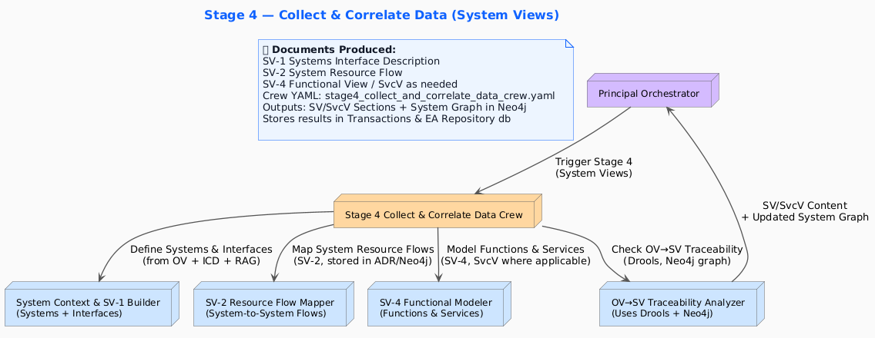

Stage 5 — Standards Views (PV / StdV)
Purpose:
Document technical standards, policies, interoperability, and platform constraints.
Components Used
- Milvus — Retrieve all prior stages + DoDAF PV/StdV definitions; store PV chunks
- Drools — Standards compliance + policy rules
- Neo4j — Map standards to systems & components
- PostgreSQL — Store PV/StdV outputs
- MinIO — Store related attachments/schemas
- Redpanda — Console updates
- IBM Rhapsody - Standards mapping to system components, Compliance modeling (constraints, policies)

Flow Diagram:
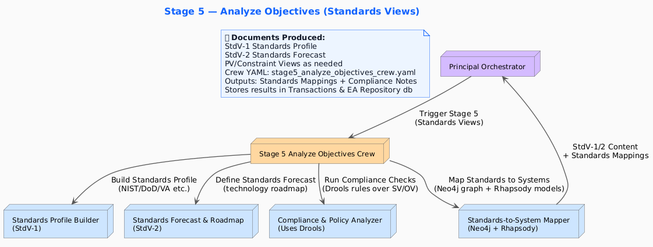

Stage 6 — Final Summary & Fit-For-Purpose Consolidated View
Purpose:
Generate the final consolidated F2P View with cross-stage consistency.
Components Used
- Milvus — Retrieve entire job memory from all stages
- Drools — Final validation of architectural completeness
- Neo4j — Retrieve graph relationships for summary
- PostgreSQL — Consolidate all stage outputs + generate final report
- MinIO — Store final DOCX/PDF artifacts
- Redpanda — Final job event broadcast
- IBM Rhapsody - Export final SysML packages, Generate architecture diagrams for the Final F2P view, Produce integrated DoDAF diagram sets (OV/SV/PV)

Flow Diagram:
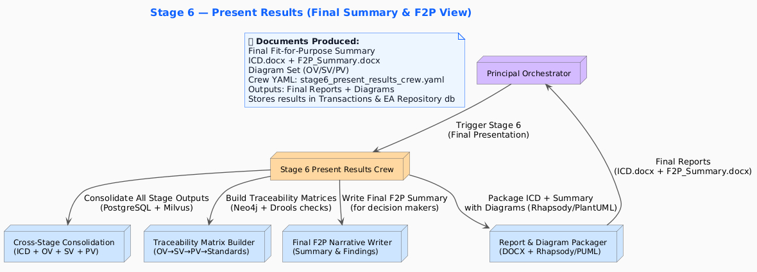

Sequence diagram showing full flow
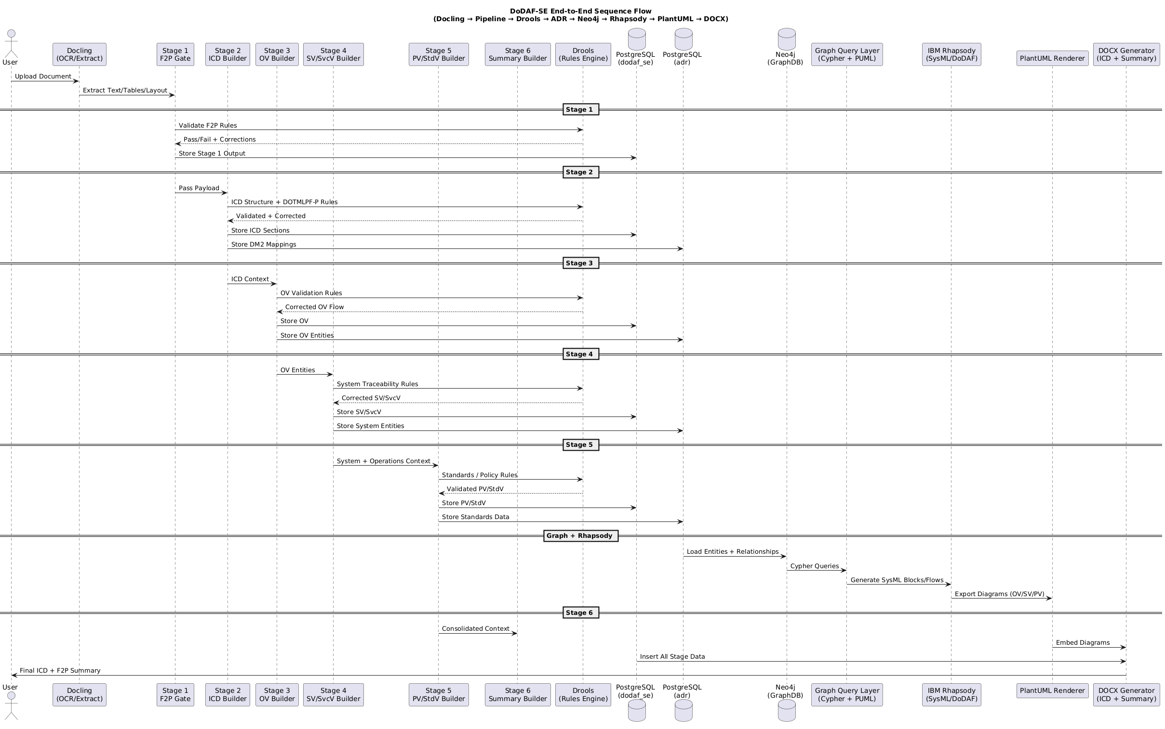

High level Component Diagram
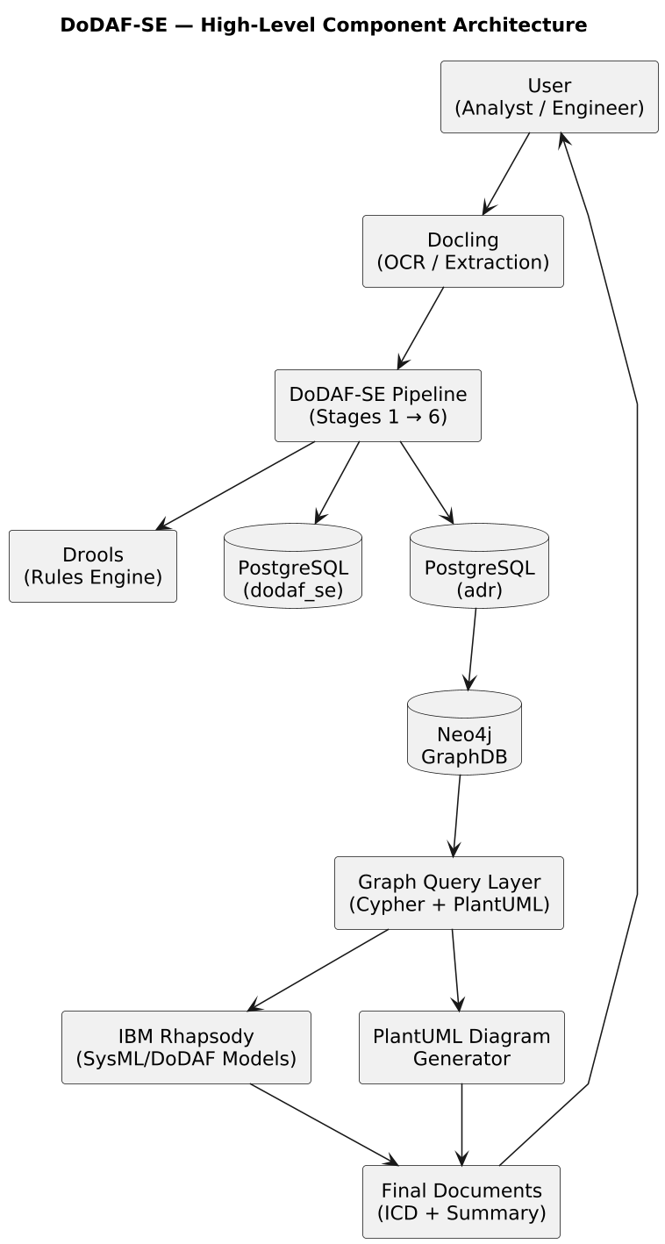

DoDAF Architecture Repository – Schema

